**COMPUTER ASSEMBLY**

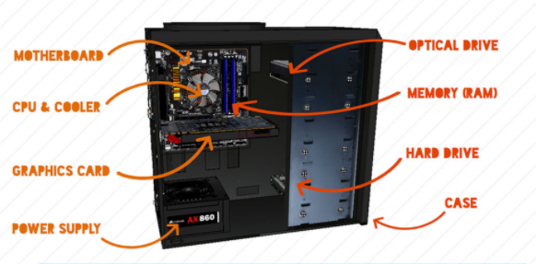

**Step 1: Open Case**

1. Remove the back screws
2. Take side cover off

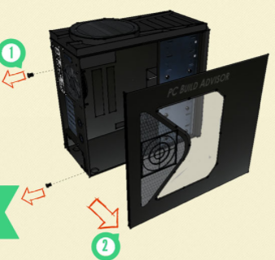

### Step 2: Mount Motherboard

1. Screw motherboard standoffs into the case
2. Punch out rear I/O plate from the case (if existing) and replace it with the motherboard I/O plate
3. Fasten the motherboard in place on top of the mounting standoffs

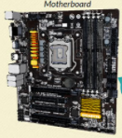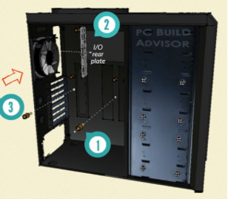

### Step 3: Mount Processor (CPU)

1. Locate the CPU socket holder on the motherboard
2. Lift up the latch lever to release and hinge open the CPU socket cover.
3. Holding the CPU by its sides, line up any alignment notches or the triangle marked on the corner of the CPU to the triangle marked on the motherboard. Gently place it straight down into the motherboard socket to seat the CPU
4. Lower the CPU socket cover over the CPU and lower the latch lever closed again to secure the CPU socket holder closed

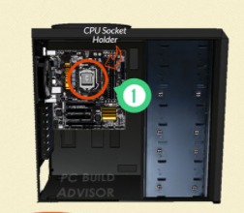

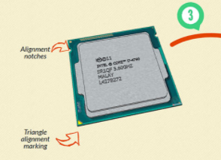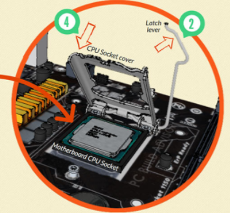

### Step 4: Install CPU Cooler

1. If required, apply thermal paste to the back of the CPU
2. Seat CPU heatsink/cooler and fix in position.
3. Plug the power cable attached to the cooler fan into the motherboard connector.

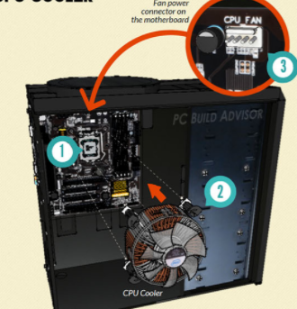

**Step 5: Install Power Supply (PSU)**

1. Mount the power supply and fasten with screws to the case mounting points
2. Plug the largest cabling connector from the power supply cabling into the motherboard power connector.
3. Plug the 8-pin cabling connector from the power supply cabling into the CPU power connector

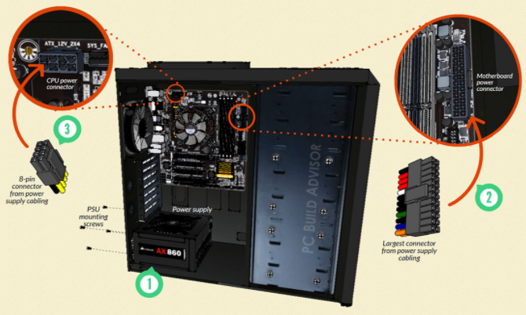

**Step 6: Mount Memory (RAM)**

1. Press to open the clips at both ends of the RAM mounting slots
2. Line up the notch on the RAM stick with the mounting slot
3. Seat the RAM and press it firmly down into the slot. The tabs should automatically latch closed as you press the RAM down, securing the RAM in place
4. Install any other RAM sticks using the same process

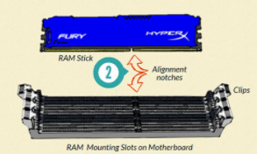

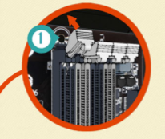

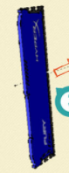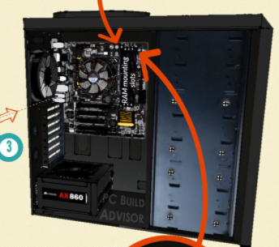

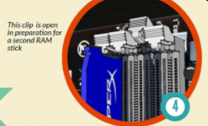

**Step 7: Install Graphics Card**

Not all computers have a dedicated graphics card. If you have decided to use the on-board graphics of your motherboard instead of installing a dedicated graphics card, you can skip this section.

1. Remove the expansion slot covers from the rear of your case where the graphics card will sit
2. The graphics card slots into a PCI expansion slot on the lower half of the motherboard. Line it up and press down firmly to seat the card.
3. Put in the screws to hold the graphics card in place
4. Plug in the power connector cables from your power supply into the graphics card power connector (if existing – not all graphics cards required external power)

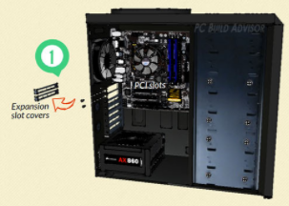 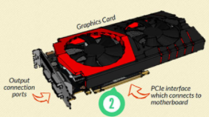

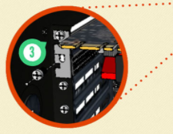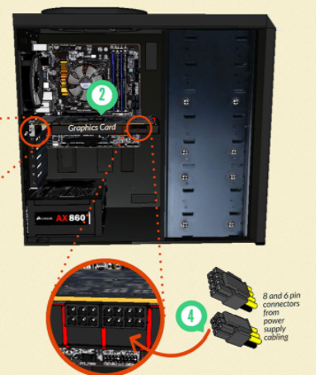

### Step 8: Mount Storage Drives

1. Mount storage drives in the case drive bays. Fix the drive in place with screws through the case frame into the case mounting holes located on the storage drive
2. Connect the drive to the motherboard using a SATA cable
3. Plug in power cabling to the storage drive
4. Mount any other storage drives in the same way

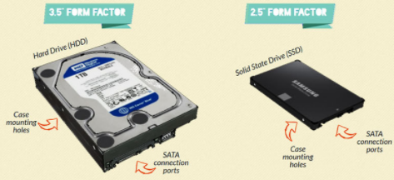

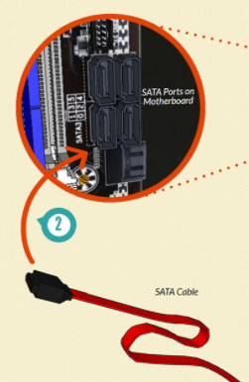 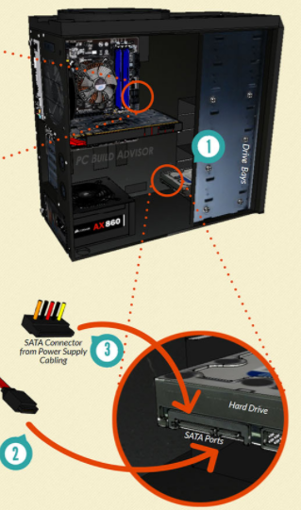

### Step 9: Connect case fans and front panel connectors

1. Mount any case fans within your case as required using the supplied screws or clips
2. Connect any case fan power connectors to the multiple fan headers located at various places on the motherboard.
3. Identify the cabling from the front panel ports of your PC. These front panel connectors will need to be plugged into the motherboard so that buttons and inputs/outputs (I/O) on your case front panel will work
4. Connect any front panel audio connectors to the the motherboard front audio header
5. Connect any front panel USB connectors to the motherboard USB headers
6. Connect the front panel case connectors to the motherboard front panel I/O headers

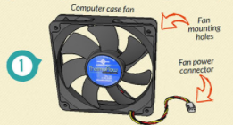

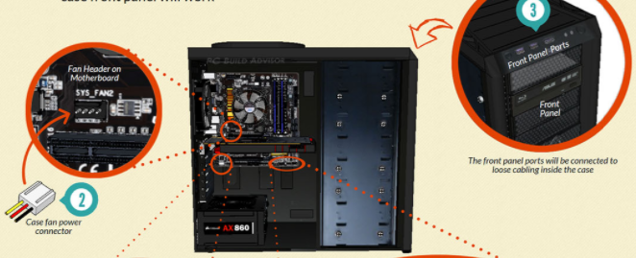

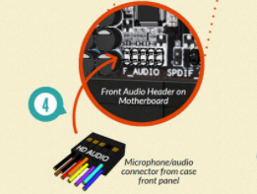 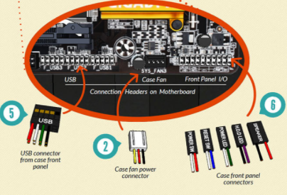

### Step 10: Close Case and Connect Peripherals

1. Place the side cover back on
2. Secure the side panel with case screws
3. Connect peripheral devices including mouse, monitor, keyboard, speakers etc.

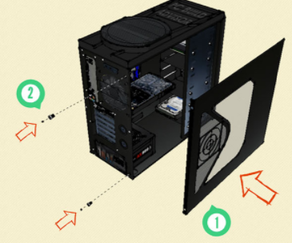

**Connecting Peripherals**

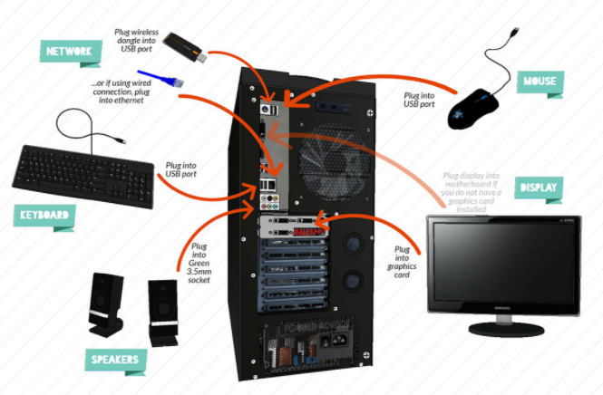

Submitted By : Prathibha S Nair

Class : S2 MCA

Roll no: 12